Ex. No. : 5

Date:

**SELECT with various clause – BETWEEN, IN, Aggregate function**

**AIM:**

To view the records from the tables using SELECT commands with BETWEEN, IN, Aggregate functions.

1)Find the average mark of “C002”.

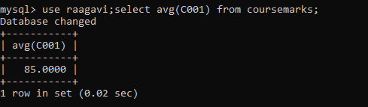

2) List the maximum, minimum mark for “C021”

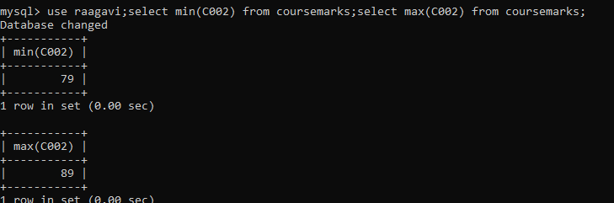

3)List the maximum, minimum, average mark for each subject in 5th semester

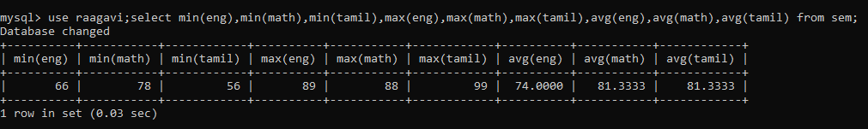

4) List the name of the courses and average mark of each courses

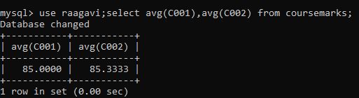

5) Calculate the sum of all the scores.

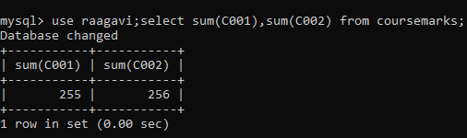

6) How many students are registered for each course? Display the

course description and the number of students registered in each course

